**How Install or Repair a Windows Update Installation**

This document aims provide guidance in either repairing a Windows update installation/uninstall, or if the windows update doesn’t register correctly in the registry.

Steps:

1. Open an Elevated Command Prompt and run sfc.exe /scannow

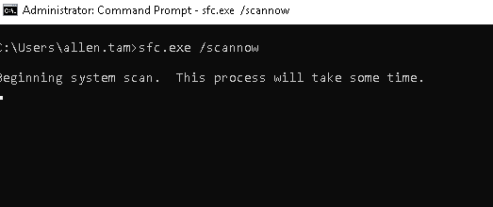

1. Next run the following command. Dism.exe /online /cleanup-image /restorehealth

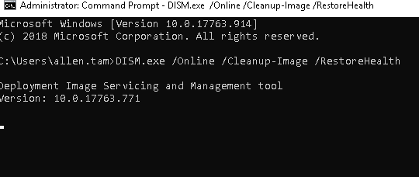

1. Next you can try to run windows update or you can uninstall then re-install it.
2. If windows update still won’t install or you decided to uninstall it there are 2 options.
3. You can run systeminfo.exe it will show you all the installed updates. Then run wusa /uninstall /kbxxxx /quiet /norestart
4. Or you could run “dism /online /get-packages /format:table” to list all the installed packages. Then run “dism /online /remove-package /packagename:name here”
5. Next to install or force a reinstall you can do the following steps:
6. Open file explorer, go to c:\windows\softwaredistribution\download\sharedfilecache and find your update package (.cab file). If it doesn’t exist go onto the WSUS server or pull it from another machine that has it installed properly.

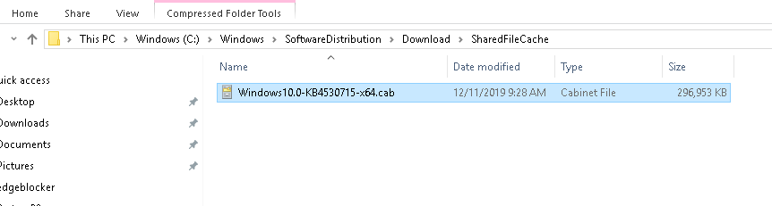

1. Copy the file to c:\temp and run the following commmand:

Dism.exe /online /add-package /packagepath:c:\temp\xxxxx.cab

This should cover most issues with windows update installations.